



Waste Management Forecasting

LAB MANUAL

Disclaimer: The content is curated from online/offline resources and used for educational purpose only
To create the Waste Management Forecasting Using RNN

Objective:
- Handle missing data, normalize the values, and convert time-series data into a suitable format for RNN input.
- Design an RNN architecture capable of capturing temporal dependencies in waste generation patterns.
- Split the dataset into training, validation, and test sets to ensure robust model evaluation.
- Implement the model in tools that help to optimize waste collection schedules and recycling strategies.

Problem Statement:
Develop a Recurrent Neural Network (RNN) to forecast waste generation trends based on historical waste management data. This model will help optimize waste collection schedules, predict landfill usage, and support recycling initiatives by analyzing temporal patterns in waste generation.

Equipment Required:
- Python installed with Jupyter Notebook / VS Code / Google Colab
- Libraries: pandas, numpy, matplotlib, seaborn, scikit-learn, tensorflow or keras

Prerequisites:
- Basic knowledge of Python programming and working in Jupyter Notebook or Colab
- Understanding of Recurrent Neural Networks (RNNs), especially for time-series forecasting
- Familiarity with data preprocessing techniques such as handling missing values, normalization, and time-series formatting (e.g., windowing)
- Knowledge of machine learning workflows including train-test-validation splits and evaluation metrics
- Experience with deep learning libraries such as TensorFlow or Keras for designing and training neural network models

Procedure:
- Import Required Libraries
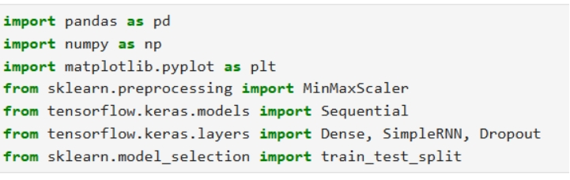
- Load the Dataset
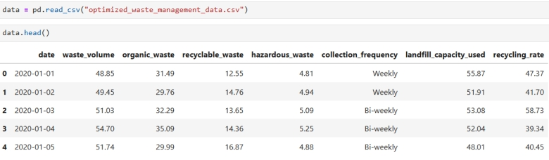
- Preprocess the Data
  - Extract the feature we want to predict
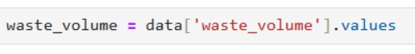
  - Normalize the data to scale between 0 and 1
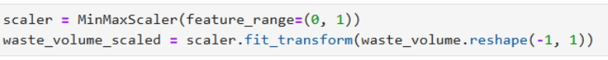
  - Define a function to create sequences for RNN input
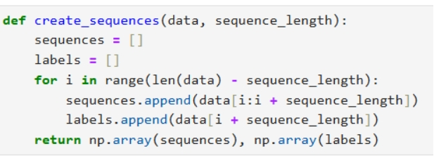
  - Create sequences (e.g., 10 previous days to predict the next day)
  - Split into training and testing sets

- Build the RNN model
  - Build the RNN model
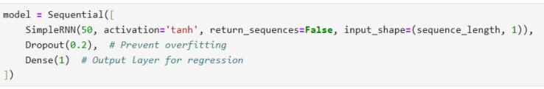
  - Compile the model
  - Display the model summary
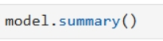
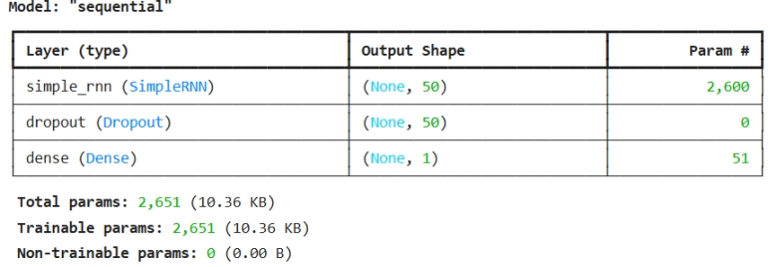
- Train the Model
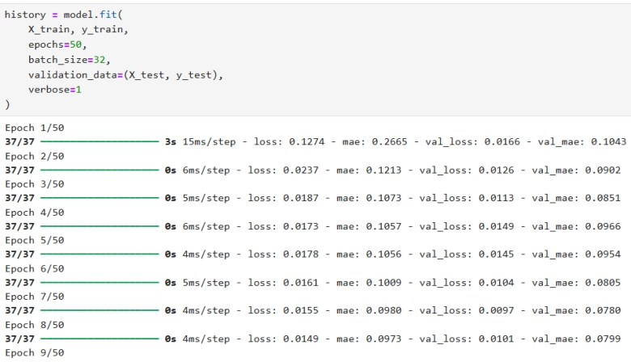
It running until 50th epoch
- Evaluate the Model
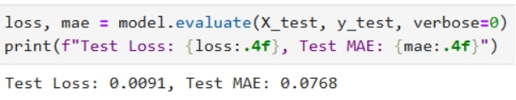
- Make Predictions
  - Predict the test set
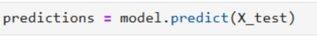
  - Inverse transform predictions and actual values to original scale
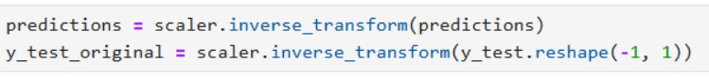
  - Plot predictions vs actual values
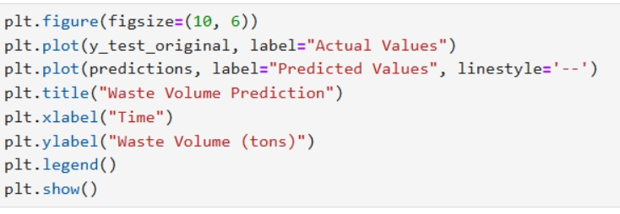

Output:
